Project Title: | School Management Portal
Prepared By: | Business Analyst
Document Type: | Business User Workflow Documentation
Version: | 1.0
Date: | July 2026

Table Of Contents:
S.No | Title | Pg. No
1 | Introduction | 3
2 | Purpose | 3
3 | Scope | 3
4 | User Roles | 3
5 | Overall System Workflow | 4
6 | Administrator Workflow | 5
7 | Teacher Workflow | 6
8 | Student Workflow | 7
9 | Parent Workflow | 8
10 | Conclusion | 9

1. Introduction
The User Workflow Document describes how different users interact with the School ERP Management System. It explains the sequence of actions performed by each user role to accomplish daily academic and administrative tasks. This document provides a clear understanding of the navigation flow and system behavior, serving as a reference for developers, testers, and stakeholders.

2. Purpose
The purpose of this document is to define the workflow of each user role within the School ERP Management System. It illustrates how users navigate through different modules and perform various operations, ensuring consistency in system functionality and user experience.

3. Scope
This document covers the workflows for the following modules:
- User Authentication
- Dashboard Access
- Attendance Management
- Assignment Management
- Assignment Submission
- Examination Management
- Notification Management
- Reports & Analytics

4. User Roles
Role | Responsibilities
Administrator | Manages users, classes, examinations, notifications, reports, and overall system administration.
Teacher | Marks attendance, creates assignments, evaluates submissions, enters examination marks, and sends notifications.
Student | Views attendance, assignments, examination results, notifications, and submits assignments.
Parent | Monitors their child's attendance, assignment status, examination results, and notifications.

5. Overall System Workflow
Description
The overall workflow begins when a user accesses the School ERP Management System. After successful authentication, the system verifies the user's role and redirects them to the corresponding dashboard. Users can then access the modules assigned to their role, perform the required operations, and securely log out of the system.
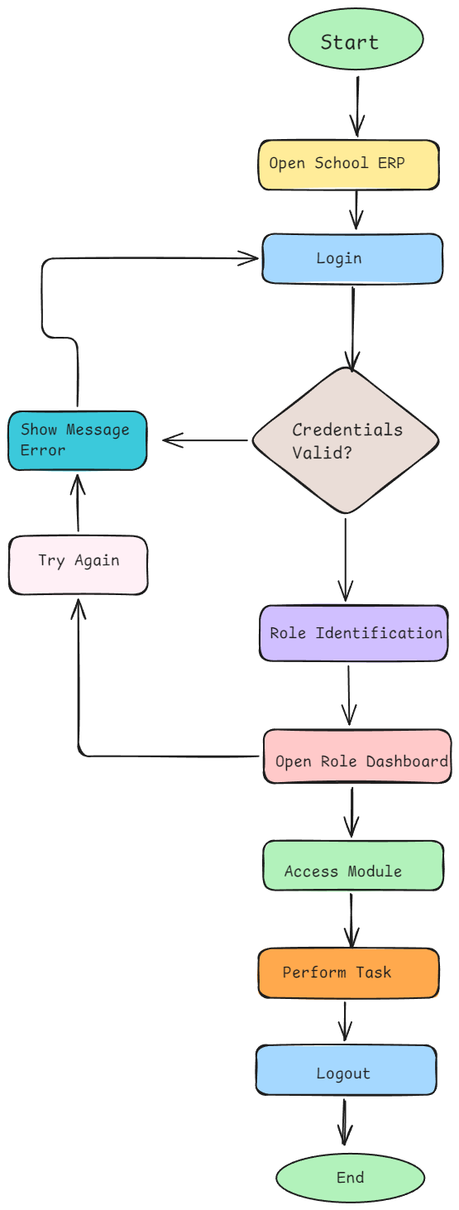

6. Administrator Workflow
Description
The Administrator is responsible for managing the overall system. After logging in, the administrator can manage student, teacher, and parent records, configure classes, oversee examination activities, publish notifications, generate reports, and monitor system operations before logging out.
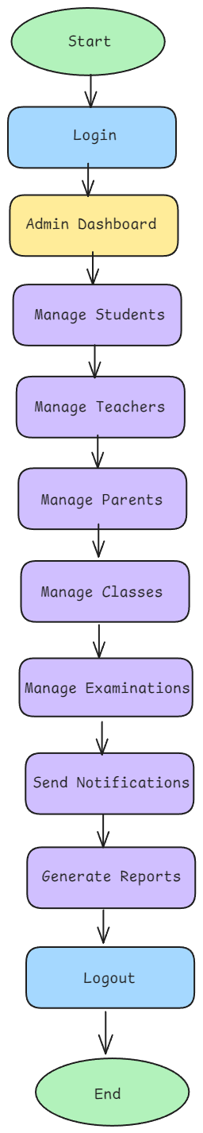

7. Teacher Workflow
Description
Teachers log into the system and access the Teacher Dashboard. They manage attendance, create assignments, review assignment submissions, upload examination marks, publish results, send notifications, and view academic reports before ending their session.
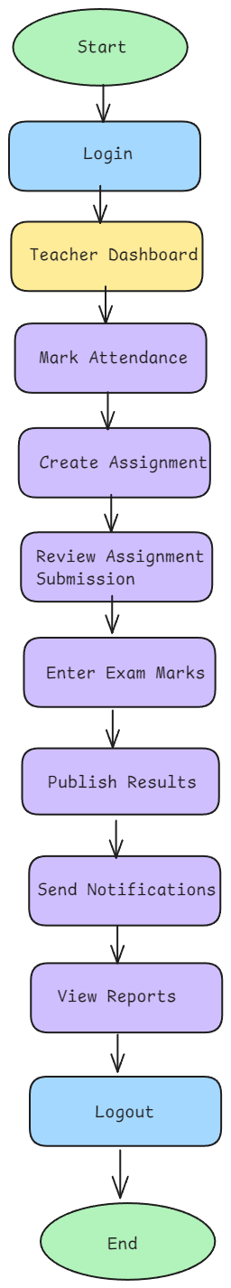

8. Student Workflow
Description
Students log into the system to access their dashboard, where they can view attendance records, assignments, examination results, notifications, and profile information. Students can also submit assignments and track their academic progress before logging out.
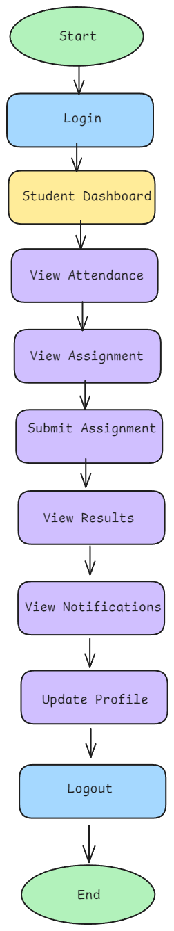

9. Parent Workflow
Description
Parents access the Parent Dashboard to monitor their child's academic activities. They can view attendance records, assignment status, examination results, and notifications, enabling them to stay informed about their child's progress before logging out.
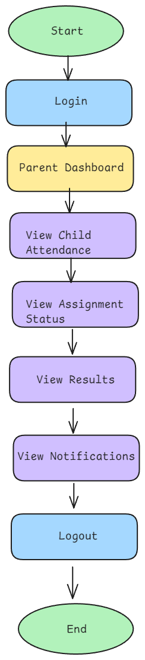

10. Conclusion
The User Workflow Document provides a clear representation of how each user interacts with the School ERP Management System. The workflows help stakeholders understand the sequence of operations performed by different user roles and serve as a reference for system development, testing, and future enhancements.

